Group 2 – Team name TBD!

Rebecca Leeds, Maria Dong, Ryan Jones, Amber Pizzo

**A brief articulation of your chosen topic and rationale**

A dashboard of 2020: This year has had so many major events in the United States, and not all of these are related to COVID. We wanted to give users the choice to look at aspects of the year that interest them.

Contains: various interactive perspectives of the year 2020 in United States, including social media trends, financial data, racial issues, fire tracker/air pollution

**Data to be included:**

* Stock data - TBD
* Unemployment data by different demographics – Statista datasets
* Mobility data - <https://github.com/OpportunityInsights/EconomicTracker>
  + Time spent at home, stores, parks, etc
* Geomapping - Fires, pollution, BLM protests
  + <https://data-nifc.opendata.arcgis.com/datasets/wildfire-perimeters/geoservice>
  + Pollution TBD
  + <https://www.kaggle.com/snehalshokeen/blm-protest-locations>
* Twitter trends/Google trends
  + <https://us.trend-calendar.com/trend/2020-08-01.html> (maybe)

**Additional JS library**

* Anime.js
* Google charts

**Screenshots of “inspiring” visualizations**

Dashboard snapshot inspiration:

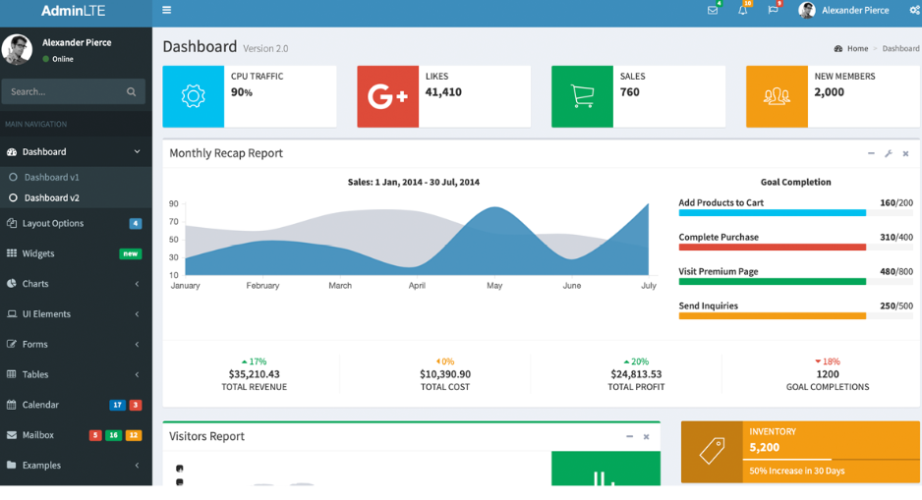

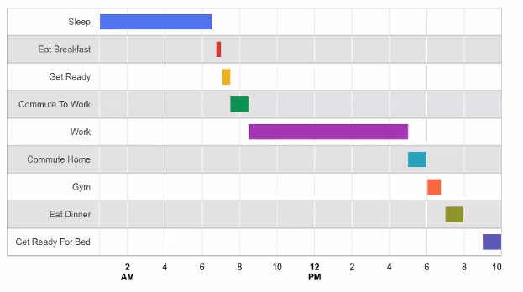

Ribbon graph

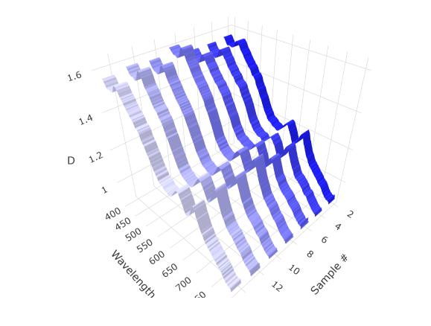

Animation (add/remove rows button):

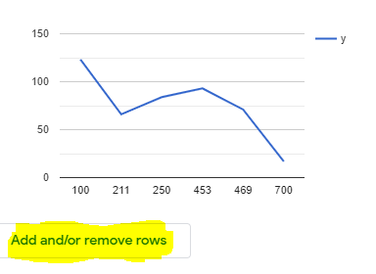

Date slider

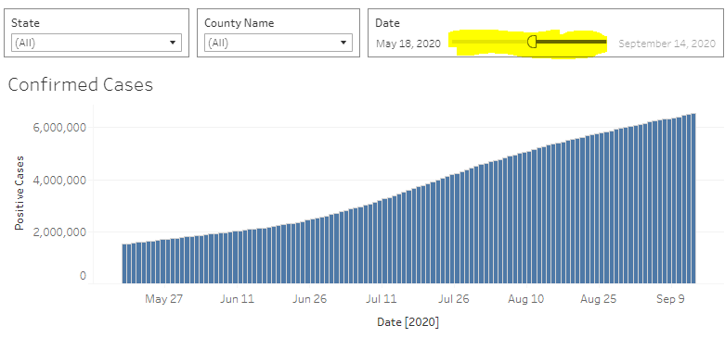

**Basic sketch of final dashboard:**

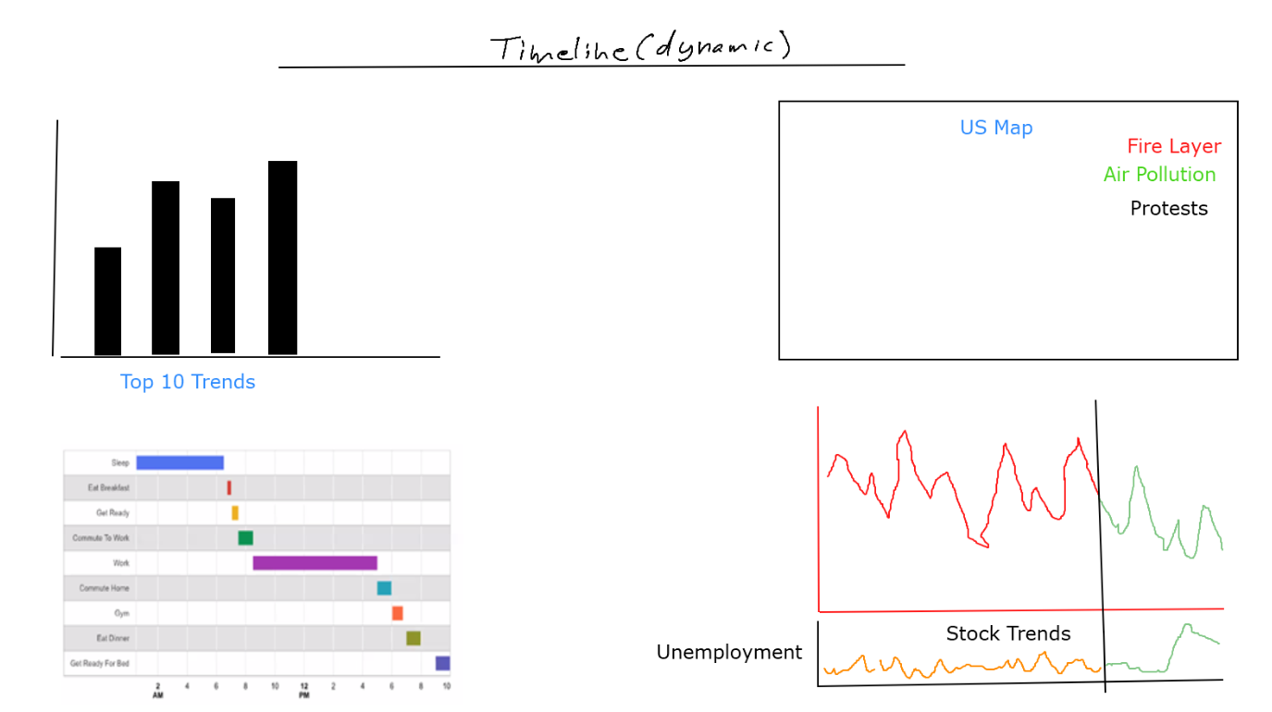

**Github Repo:** <https://github.com/apizzo1/Project-2>